I Wanna Be Like You
Carey Rasmussen
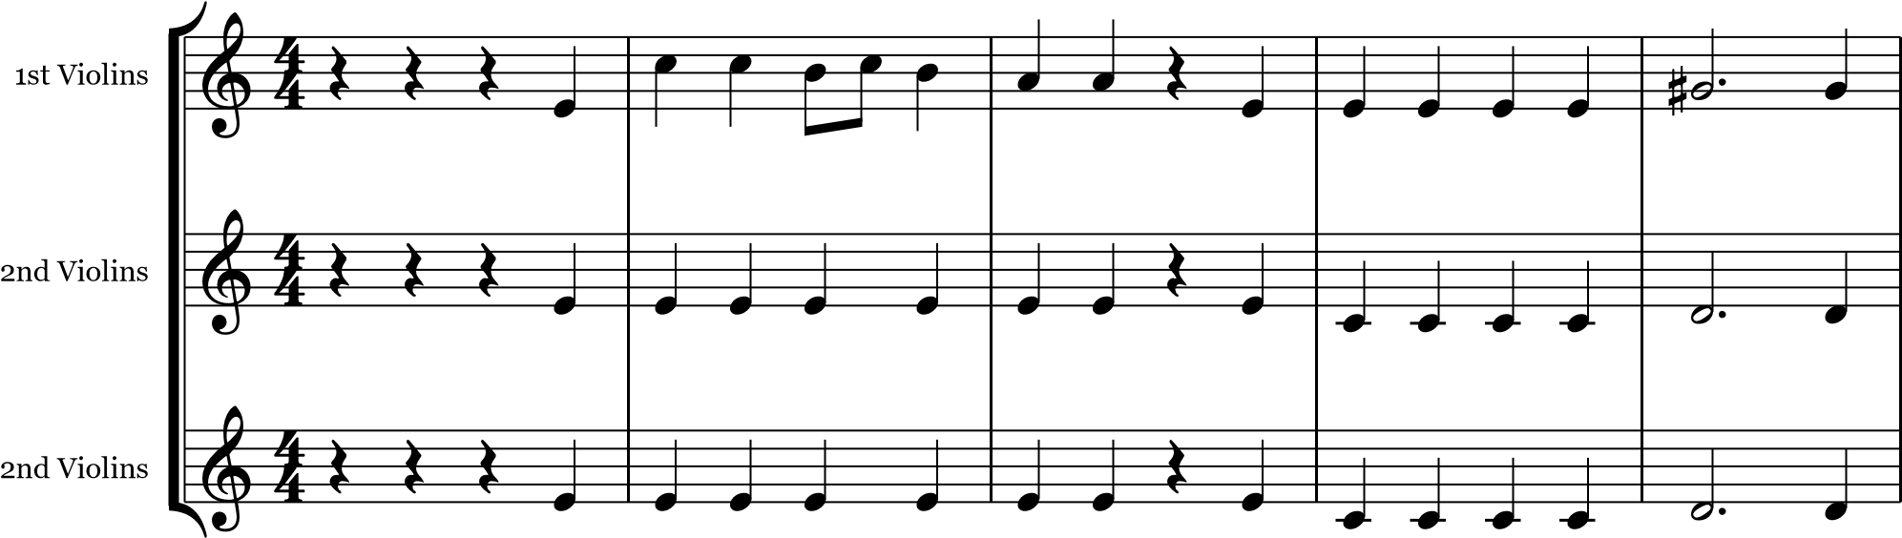
6
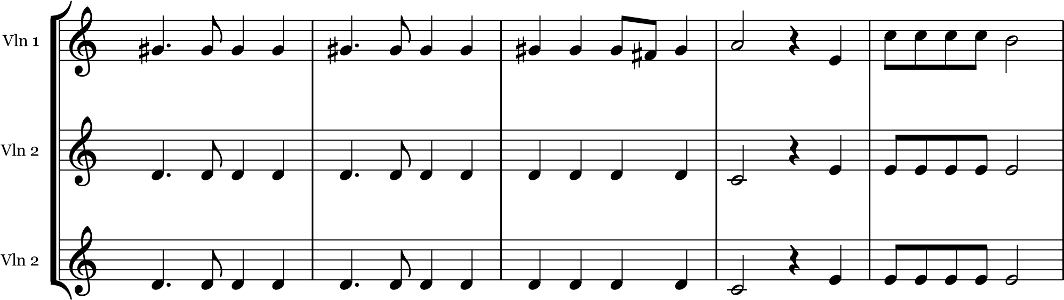
11
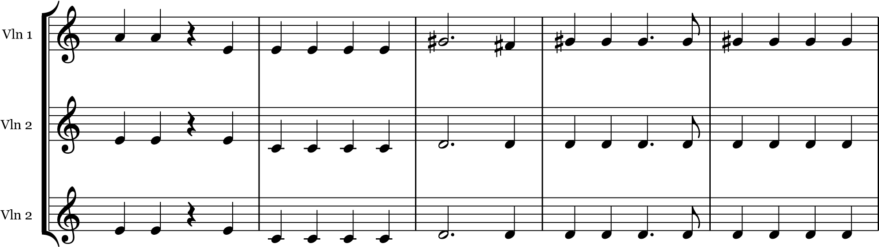
16
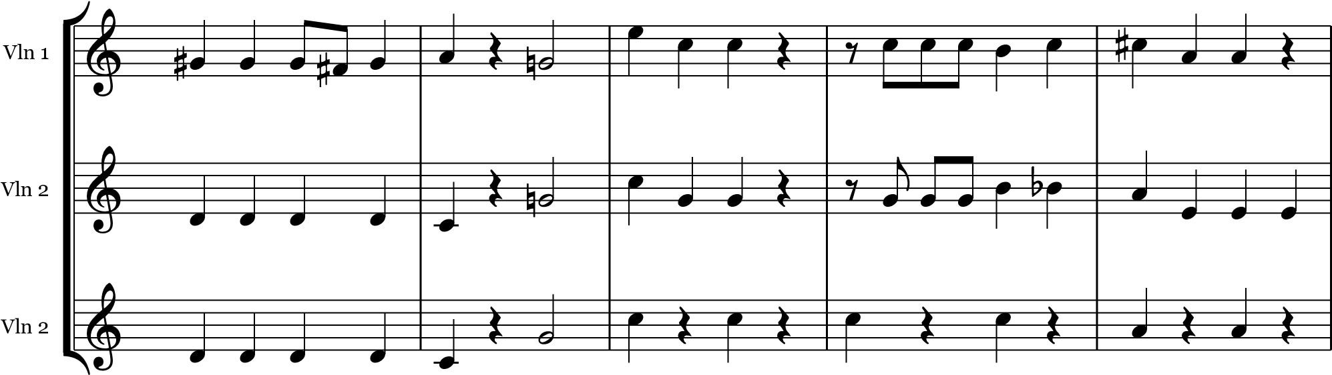
21


Vln 1
Vln 2
Vln 2































25


Vln 1
Vln 2
Vln 2



































29


Vln 1
Vln 2
Vln 2






























2

